South Tyneside Safeguarding Children Partnership
Weapon / Knife
Crime Protocol

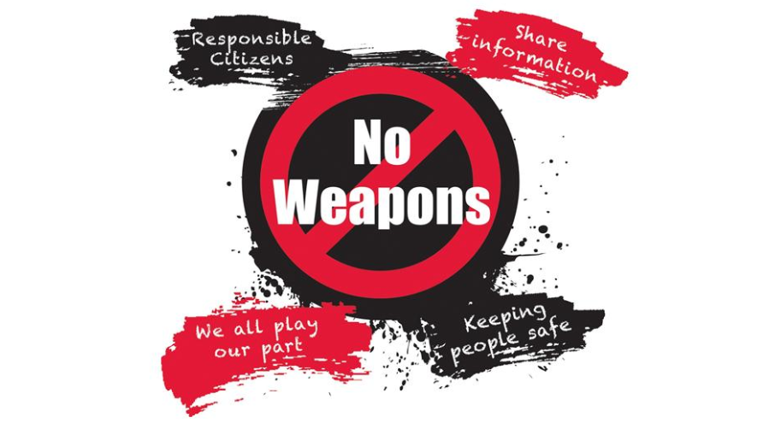

Issue Date: | September 2019
Review Date: | January 2020

CONTENTS

1. Background 3

2. Protocol Objectives 3

3. Children’s Rights 3

4. Legislation, Law and Definitions 3

Offences 4
Powers to Search 4
Power of Seizure, Retention and Disposal 4
BB Guns (Plastic Pellet Guns) 5
Taser Guns (Stun Guns) 5

5. Process Flowchart 6

APPENDICES

1. Weapon/Knife Crime Incident Report Form 8
2. Student Risk Assessment (Parts One and Two) 10
3. Knife Crime Prevention Form 15

1. Background

1.1 When a young person makes a decision to take a knife, blade or other offensive weapon into a school, it is a serious one. With potentially fatal consequences, it can have a devastating impact upon their future whether they are a victim or a perpetrator.

1.2 In June 2018, the Government published its Serious Violence Strategy which sets out the response to serious violence and recent increases in knife crime, gun crime and homicide. In September 2019 the updated Keeping Children Safe in Education Guidance (paragraphs 29 and 30) clearly states that school safeguarding policies should capture the emphasis on serious violence.

1.3 South Tyneside Safeguarding Children Partnership has developed interim Weapon/Knife Crime Protocol to provide direction, guidance and support for Head Teachers/school leaders when dealing with knives, blades and offensive weapons.

2. Protocol Objectives

2.1 The Weapon/Knife Crime Protocol aims to:

- Provide an overview of the Law and Legal Definitions relating to knife and weapon crime
- Provide guidance with regard to the searching of pupil’s personal belongings
- Provide interim procedural and operational guidance with regard to weapon / knife crime incidents in school

3. Children’s Rights

1.3 Our responsibilities are set out in the United Nations Convention on the Rights of the Child.

“Children have the right to be protected from being hurt and mistreated, physically or mentally. Governments should ensure that children are properly cared for and protect them from violence, abuse and neglect by their parents, or anyone else who looks after them.” (Article 19)

4. Legislation, Law and Definitions

Possession of a weapon is a criminal offence.

4.1 A weapon is any article made or adapted for use to cause injury to the person, or intended by the person having it with him for such use by him, or some other person.

4.2 The Criminal Justice Act 1988, Sect 139A creates the offence of possessing an article with a blade or sharp point or an offensive weapon on school premises.

4.3 Offences

- Possession of an Offensive Weapon (Section 1 Prevention of Crime Act 1953) prohibits the possession in any public place of an offensive weapon without lawful authority or excuse. The term "offensive weapon" is defined as: "any article made or adapted for use to cause injury to the person, or intended by the person having it with him for such use".

- Possession of Blades / Points (Section 139 of the Criminal Justice Act 1988) prohibits having an article with blade or point, in a public place (including a folding pocket knife if the cutting edge of its blade exceeds 7.62cm (3 inches).

NB: These offences can be committed at any time of day (not just during school hours) as long as the land is normally used as a school premise (e.g. for the normal academic year.

4.4 Powers to Search

The Education Act 1996 (Sections 550ZA, 550ZB) sets out the full conditions before a search can be carried out on a pupil or their possessions and can be found at: https://www.legislation.gov.uk. Initial guidance is as follows:

- The Head Teacher of the school or person authorised by them may carry out the search

- The search may be carried out only where the member of staff and pupil are on the school premises OR they are elsewhere and the member of staff has lawful control or charge of the pupil

- The authorised person may not require the pupil to remove any clothing other than outer clothing and must be of the same sex as the pupil

- The search of the pupils possessions must take place in the presence of the pupil and another member of staff (unless the authorised person believes there is a risk that serious harm will be caused to any person if the search is not carried out as a matter of urgency)

4.5 Power of Seizure, Retention and Disposal

The Education Act 1996 (Section 550Zc) states what powers are available to a Head Teacher or other authorised member of staff who discover prohibited items when searching a pupil or their possessions under Section 550ZA

The Head Teacher or other authorised person may seize any of the following found in the course of a search under Section 550ZA:

- Anything which they have reasonable grounds for suspecting is a prohibited item (knife, blade, offensive weapon etc.)
- Any other thing which they have reasonable grounds for suspecting is evidence in relation to an offence

These articles MUST be delivered to a police constable as soon as reasonably practicable.

4.6 BB Guns (Plastic Pellet Guns)

The possession of these types of guns under legislation is not an offence as they are deemed to be toys. However, if from a school perspective they breach school rules, they could be seized and retained under the Education Act. If an item is found which is suspected to be a gun and it cannot be ascertained whether it is a genuine firearm or a BB gun, it should always be treated as a firearm and the police called to make that decision.

Possession of these items becomes an offence when a person is misled into believing they are genuine firearms in order to provoke fear; the BB gun may then be classed as an imitation firearm. Circumstances giving rise to this belief may include use:

1. In connection with a robbery
2. To threaten someone
3. As a weapon to assault someone, e.g. pellet injuries
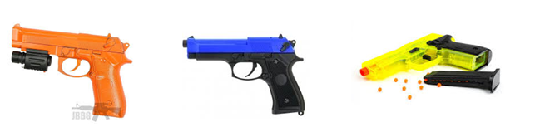
4.7 Taser (Stun Gun) – Prohibited Weapon under the Firearms Act

Classed as firearms, Tasers discharge a high level of voltage designed to incapacitate a person; any possession of such items is a serious offence and should be reported to the police. Disguise or concealment of a Taser as another item eg mobile phone, is considered a serious aggravating factor. Tasers may be designed to look like torches or mobile phones, but will usually feature metal prongs which are fired to penetrate the skin and discharge an electrical current via fine filaments. Stun guns use metal electrodes to deliver shocks via direct contact.

4.8 There will be instance where there are suspicions a young person is involved in knife / weapon crime. As preventative measures, Weapon / Knife Crime Prevention Form at Appendix 3 should be completed. The following referrals to diversionary programmes should also be considered:

- Operation Divan Ages 10-18 years, for those involved with weapons
- Operation YOLO Ages 8-14 years, for those involved with gang culture

Further details can be obtained from the Police

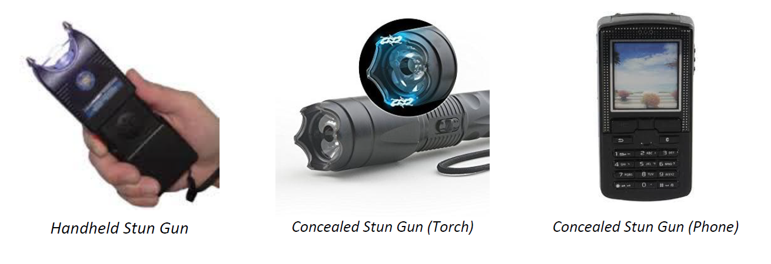
If students are discovered in possession of these articles the police MUST be contacted promptly to seek further advice and guidance.
PROCESS FLOW CHART
Weapon / Knife Crime Incident
Head Teacher / Senior Leader Notified and will lead action to minimise risk of harm to everyone
Parent/Carers of Offender and Victim to be notified
Inform Police

Search Offender in line with guidance at Section 4.4
If a weapon is found keep in a secure, locked place until handed over to Police
Complete Weapon/Knife Incident Report form to be completed
(Appendix One)
Head Teacher/ SLT agree level of Information Sharing with school community / parents / wider community

Team Around Child
Risk Assessment Meeting
Head Teacher/SLT to convene within 2 working days to complete Risk Assessment Parts One and Two
(Appendix Two)

Not Exclude
Risk Assessment to be used to agree Return to School Plan which must be monitored and reviewed

Exclude
Completed Risk Assessment to be shared through Fair Access / New School

No Injury
Injury
Follow First Aid Protocol and Call Ambulance
Risk of Threat of Immediate Harm Call 999

Key Contacts
Northumbria Police | 999 Emergency  101 Non-Emergency
Barnardo’s | 0191 293 1400
Childline | 0800 111
NSPCC | 0808 800 5000

INSERT SCHOOL / COLLEGE
LOGO HERE (Optional)
Appendix One

WEAPON/KNIFE INCIDENT REPORT FORM
To be completed by Head Teacher/Designated Member of Staff as soon as notification of incident received (or within as reasonable time frame as practicable)
Date and Time of Incident: |  |  |  |  | Location of Incident:
Student Details
Name: |  |  | DOB |  |  | Year Group
Address: |  |  | Is the student:  CP  CIN  LAC  Early Help  SEN  Other Services |  |  | Previous history of aggression / violence / weapon:  Yes No  Dates / Details:
Parent Details
Name: |  |  | Contact Details: |  |  | Informed of incident:  (date / time)
Details of the Incident (Please Include Details Of Any Witnesses)

CCTV available Yes No
Weapon Type: |  |  | Weapon Confiscated: |  |  | Weapon Secured (where):
How was the incident raised?  Student self-disclosed  Reported by another pupil  Weapon seen by staff  Member of public  Other (provide detail) |  |  |  |  | Was anyone injured in the incident?  Student with weapon  Other pupil  Staff member  Member of public  Other (provide detail)
Provide detail of those injured including the injuries sustained and treatment given
(copy of first aid docs attached if possible)

What immediate action has been taken to safeguard students, staff and school users?

Child/Young Person’s Views:

Parent’s Views:

Police informed | 999 | 101 |  | Other services informed(details:
Give details of police response:

Copies of this form shared with (details:)

Person completing this form: |  |  | Designation: |  |  | Tel:  Email:
Date: |  |  |  |  |  | Time:

STUDENT RISK ASSESSMENT (PART ONE)
Appendix 2
Following a weapon / knife incident a Team around the Child Risk Assessment meeting will be arranged which will seek to identify how the student and school community can be supported to reduce the likelihood of a further incident recurring.

All partners have a responsibility to share information appropriately as in accordance with the Keeping Children Safe in Education guidance.

Designation | Name | Invited (Yes/No) | Attended (Yes/No)
Head Teacher of School
Chair of Governors
Designated Safeguarding Lead
Head of Year
Guidance Teacher
Services for Young People
Northumbria Police
Health (School Nurse)
NTW Children and Young People’s Service (CYPS)
Mental Health Champion
Children and Families Social Care
Parent/Carer
Young Person
Other Services Involved with the Child

Name of Student: | Year Group/Form Class:
Date of Incident: | Date of Team around the Child Risk Assessment Meeting:

What was the student referred for?  Verbal Abuse Physical Abuse Weapon Other | Prior History / Previous Incidents
Specific Subjects / Environments that are potential triggers:

What are the Potential Triggers?

Authority Bullying Change of Routine / Staff Frustration

Home Circumstances Lack of Medication Learning Difficulties (diagnosed / undiagnosed) Medical Condition

Mental Health Issues Personality Clash (who) Provocation Safeguarding Concern

Sexual Awareness Social Media Substance Misuse Other (specify)

What Happens – What are the resulting Actions / Behaviours?

Arson Risk Biting Bully others Climbs Damages Property

Displays Inappropriate Behaviour False Allegations Graffiti Improvise items as weapons Kicking Locks themselves in

Lies Lunges May find a Weapon Punching Refuses to move

Refuses to Obey requests Runs Away Shouting Social Media Posts Spitting

Steals Total Shut Down Throws Objects Verbal Abuse / Threats Videos Incidents

Other (specify)

Frequency / Potential for the incident to reoccur:  Before / After School Every Period Breaks / Lunches  Daily Weekly Constant | Who may be affected by the risk of an incident reoccurring?  Other Students Staff Members of the Public  Other (specify)
Child/Young Person’s Views:

Parent’s Views:

Any additional comments / observations / actions already taken (ie Exclusion):

The information in Part One should be used to agree Part Two of the Risk Assessment

Student Risk Assessment – (Part Two)
This section should be completed by the Team around the Child once part one has been discussed and agreed. Part Two will help identify what control measures are needed and minimise the risk of an incident recurring. It should also detail the arrangements for monitoring and review.
Reason Student Referred / Type of Incident | Triggers for Behaviour | Behaviours displayed if triggers cannot be controlled | Control Measures to address triggers | Control Measures those affected | Additional Control Measures to be considered | Staff responsible for monitoring measures and how will this be done | Other observations / comments | Review arrangements

EXAMPLE
Reason Student Referred / Type of Incident | Triggers for Behaviour | Behaviours displayed if triggers cannot be controlled | Control Measures to address triggers | Control Measures those affected | Additional Control Measures to be considered | Staff responsible for monitoring measures and how will this be done | Other observations / comments | Review arrangements
Physically assaulting a member of staff and threatening with a craft knife | Weekly  Same lesson each week – mornings period one (has usually arrived late)  Issues with other students in that lesson  DV at home – part of Operation Encompass | Pupil picks up objects and throws them at staff  Can lunge and kick at other students  Spits  Can attempt to run away  Refuses to follow requests and member of SLT needs to be called | Daily Catch Up  Assess student for mood before the lesson (meeting with pastoral staff or Mental Health Champion  Staff aware of procedures to alert others if student attempt to run away  Know key areas they are to be found – provide safe space (ask student to agree) | Staff given instructions on how to deal with students following completion of Risk Assessment (share with teaching staff with student agreement)  Ensure student aware of procedure to follow should they need to leave the class  Procedures agreed for alerting On Call | “Chill Out” room used for short durations  Support of key pastoral staff (agreed by student)  Parent /carer easily contactable to attend school as required  Educational Psychology referral  SEN needs assessed | Form Tutor  Pastoral Staff  SLT Link  Staff to compete report and log on system  Pastoral support meet with student at agreed times for debrief  Parent /Carer to be updated at agreed times | May have to consider a move of class  Share information with other agencies if involved  Any other changes that may affect student | To be reviewed daily and weekly at agreed meetings with pastoral staff and SLT  Report to be monitored and reviewed

Appendix Three
INSERT SCHOOL / COLLEGE
LOGO HERE (Optional)

WEAPON/KNIFE PREVENTION FORM
To be completed by Head Teacher/Designated Member of Staff where there is a suspicion that a young person may be involved in weapon/knife crime.
Student Details
Name: |  | DOB | Year Group
Address: |  | Is the student:  CP  CIN  LAC  Early Help  SEN  Other Services | Previous history of aggression / violence / weapon:  Yes No  Dates / Details:
Parent Details
Name: |  | Contact Details: | Informed of suspicion:  (date / time)
Rationale for suspicion (give as much detail as possible include source of information where possible)

CCTV available Yes No
Weapon Type (if known)
What actions are being taken by the school to support the young person?

Referrals
Operation Divan : 10-18 years involved with weapons
Operation YOLO : 8-14 years – involved with gang culture
Youth Justice Service
Other services (please state)
Child/Young Person’s Views:

Parents / Carers Views:

Copies of this form shared with (details:)

Person completing this form: |  | Designation: | Tel:  Email:
Date: |  |  | Time:

Resources
https://www.pshe-association.org.uk/curriculum-and-resources/resources/home-office-knifefree-lesson-plans-ks34-%E2%80%93-updated
https://www.safe4me.co.uk/portfolio/knife-crime/
https://www.safe4me.co.uk/portfolio/knife-crime/
https://noknivesbetterlives.com/practitioners/resources/

You Tube Videos
There are also a wide range of information videos for young people, parents and carers to access free of charge on You Tube which are suitable to be shared in PSHE lessons, at parent/carer events and on social media.
Marks Story, One Life Many Victims - https://youtu.be/FvC884FdpqM

Government Reports on Serious Violence
https://www.gov.uk/government/publications/serious-violence-strategy
https://assets.publishing.service.gov.uk/government/uploads/system/uploads/attachment_data/file/785055/Knife_crime_safeguarding_children_and_young_people_110319.pdf

Websites
www.benkinsella.org.uk
www.respectme.org.uk –

